 | On this fragmentary marble relief Zeus is represented sitting on a throne beside an altar. There is an eagle underneath the throne. Zeus holds a phiale (shallow bowl) which would have been used in ritual to pour a libation. | Athenian marble votive relief sculpture  Shefton Collection, Great North Museum (inventory number 810)  375-350 BC  Height 17 cm  Case 1

 | This red-figure volute krater, made in Athens in the fifth century BC, would have been used for mixing wine and water at the drinking party. The Greeks always drank their wine diluted. Dionysus the god of wine is in the middle with his favourite drinking cup the kantharos. He also holds a thyrsus (fennel stalk with a pine cone on top which is often wrapped in ivy). The two women on either side of Dionysus are maenads. One holds a snake and the other has ripped a deer in half as part of the ritual. | Athenian red-figure volute krater  Shefton Collection, Great North Museum (inventory number 629)  450-425 BC  Height 50.4 cm  Case 1

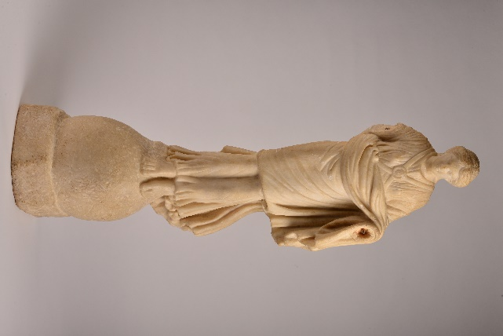 | Nike, the Greek goddess of victory, is associated with both athletic and military victories. She is frequently portrayed flying down to crown a victor with a wreath. Here she is shown landing on a globe.  This particular statuette has lost both its wings and arms, although sockets for the wings and dowels for attaching the arms are still visible.  This Nike is from the island of Corfu, where it was probably discovered in the 1820s during excavations of a temple at Kardaki. | Marble statuette of Nike  Shefton Collection, Great North Museum (inventory number 815)  100 BC-100 AD  Height 75 cm

